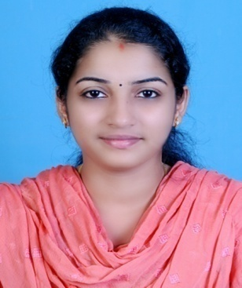

**INDHU N**

Phone : +65 90148739

Email : **indhumohan19@gmail.com**

**Objective**

To establish a long term career in the professional industry so as to assimilate long with the professional betterment of the organization by rendering my best.

**Technical Profile**

2+ years professional experience in Web applications maintenance and development using PHP Frameworks[Laravel Framework] and Core PHP

**Technical Skills**

Programming Languages : **PHP[LARAVEL FrameWork],C,C++**

Web Technologies : HTML, CSS,,Bootstrap,Wordpress,Jquery,Javascript.

Database Tools : **MySQL**

Operating Systems :  **Windows 98/XP/Vista/Windows 7/Windows 8.**

Office Tools : **Good Knowledge in MS Office.**

**Work Experience**

|  |  |  |
| --- | --- | --- |
| EBS Solutions PVT LTD | 2nd February 2015 - 15th August 2015 | Junior PHP Software Developer |
| Softech WebSolutions | 15th January 2016 - 25th January 2017 | Junior PHP Software Developer |
| Vocomi Software Solutions | 1st April 2017 - 30th September 2017 | Junior PHP Software Developer |

**Projects worked upon**

**Websites**

1. Project Name : Vocosmart office (<http://atsdemo.vocomi.com)>

Username : admin Password : admin

Technology : PHP [Laravel Frame work],MySQL,JQuery

this website used for office management ,especially attendance tracking ,payrol management, and task management.

2. Project Name: Kozhikodeinfo (<http://www.kozhikodeinfo.in)>

Technology : PHP, MySQL, CSS, JQuery.

The website give the all information about the Kozhikode City.

3. Project Name: TP Tiles (<http://www.tptiles.com)>

Technology : PHP, MySQL, CSS, JQuery.

4. Project Name: Academy Of Fashion Technology (<http://www.aftfashion.com)>

Technology : PHP, MySQL, CSS, JQuery.

5. Project Name: Raanthal Restaurant ([http://www.raanthal.in)](http://www.aftfashion.com))

Technology : PHP, MySQL, CSS, JQuery.

6. Project Name: SIMS Technology ([http://www.simstechnologies.in)](http://www.aftfashion.com))

echnology : PHP, MySQL, CSS, JQuery.

**Educational Qualification**

|  |  |  |  |  |
| --- | --- | --- | --- | --- |
| **Course** | **Institution** | **Board/University** | **Year** | **Result (%)** |
| MCA | CCSIT College Manjeri | University of Calicut | 2009- 2012 | 64.8 |
| BSc. Computer  Science | AWH Special College Kallai | University of Calicut | 2006-2009 | 75.7 |
| Plus Two | G.H.S.S  Beypore | Board for Higher  Secondary  Education, Kerala | 2004-2006 | 57.5 |
| S.S.L.C | GOVT.Achuthan  G H S Kozhikode | Board for Secondary Education, Kerala | 2004 | 65.8 |

**Hobbies**

* Listening Music.
* Gathering information from internet by searching
* Interested in social Networking and social media.

**Personal Details**

Full Name : Indhu . N.

Date of Birth : 02/10/1988

Sex : Female

Nationality : Indian

Marital Status : Married

Languages Known : English ,Tamil,Malayalam

Contact Address : Nambiveettil(Ho)

Kallai(Po),

Kozhikode(Dis),

673003(Pin).

**Declaration**

I hereby declare that the above mentioned details are true to the best of my knowledge.

Place :Kozhikode

Date : **Indhu.N**